Module 3 Critical Assignment

Activity 1: Write a program that calculates the total amount of a meal purchased at a restaurant. The program should ask the user to enter the charge for the food and then calculate the amounts with an 18 percent tip and 7 percent sales tax. Display each of these amounts and the total price.

**Rationale** -

1. Get User Input for food cost and convert that to Float.

2. Sales Tax and Tip are set globally so; we can leverage this variable every time we need to use them. In future, if any of these changes, we have to update here. All other calculations remain the same. Helps to increases readability and reduce number of code lines to change/review for maintenance.

3. Format the output into currency format (zyBooks)

**Reference**:

zyBooks. (2019 August). CSC500: Principles of Programming. Module 2.19.

Screenshot with Output:

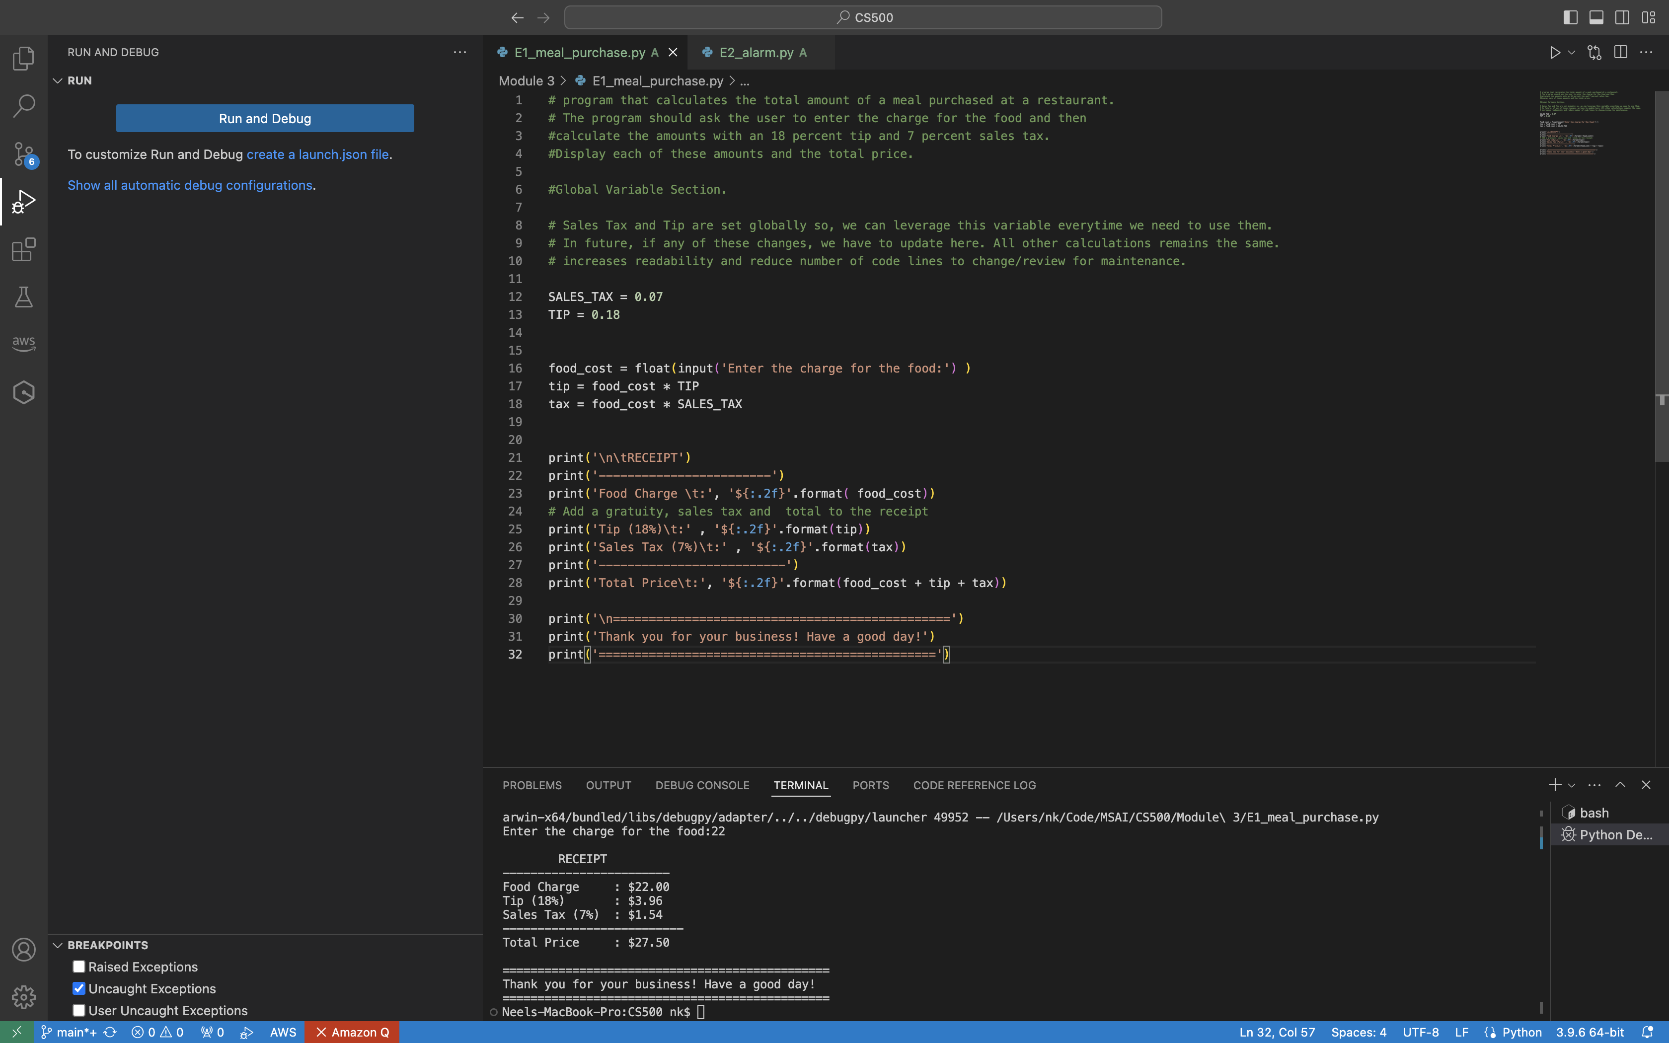

Enter the charge for the food:22

RECEIPT

------------------------

Food Charge : $22.00

Tip (18%) : $3.96

Sales Tax (7%) : $1.54

--------------------------

Total Price : $27.50

===============================================

Thank you for your business! Have a good day!

===============================================

Activity 2: Many people keep time using a 24-hour clock (11 is 11am and 23 is 11pm, 0 is midnight). If it is currently 13 and you set your alarm to go off in 50 hours, it will be 15 (3pm). Write a Python program to solve the general version of the above problem. Ask the user for the time now (in hours) and then ask for the number of hours to wait for the alarm. Your program should output what the time will be on a 24-hour clock when the alarm goes off.

Rationale:

1. Get User input as a current time and convert to int (as we are looking for whole number in hour)
2. Get User input as hours to wait and convert to int
3. Calculate time when alarm to go off using Modulo operator. The day is of 24 hours so, if any time in the day will be between 0 and 23. Modulo will exactly give us this functionality.
4. (Optional) calculate how many days to wait before alarm will go off (divide time to wait by 24 using floor division operator to get whole number)
5. (Optional) Print friendly message to interpret ‘0’ as midnight.

**Reference**:

zyBooks. (2019 August). CSC500: Principles of Programming. Module 2.7.

Screenshot of code and output:

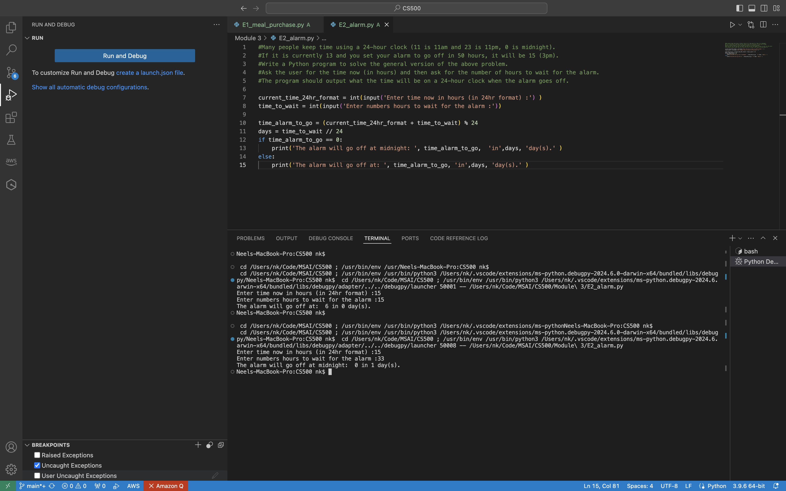

Output:

Enter time now in hours (in 24hr format) :15

Enter numbers hours to wait for the alarm :15

The alarm will go off at: 6 in 0 day(s).

Output:

Enter time now in hours (in 24hr format) :15

Enter numbers hours to wait for the alarm :33

The alarm will go off at midnight: 0 in 1 day(s).